Lab Submission: 4

Student Name: Michael Daly

Course and Section: CST8215 – 362

========================================================================

Lab 4 – Working with Postgres database and PGModeler

Please ensure you have downloaded the PGModeler application and installed it successfully to your laptop prior to beginning.

Download the HR DDL and HR DML files to your laptop

Grading: Lab 4 is worth 5 marks

========================================================================

Step 1 - using PGAdmin, execute the HR DDL and HR DML scripts to create the new tables. Remember to refresh your left side panel and show the new set of tables (2 marks)

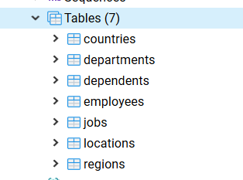

Step 2 – for each new table provide individual screenshots providing a total row count for each table (remember to include your sql statement and results) (1 mark)

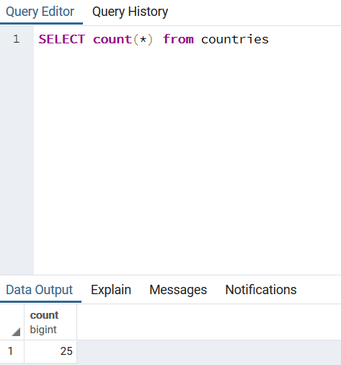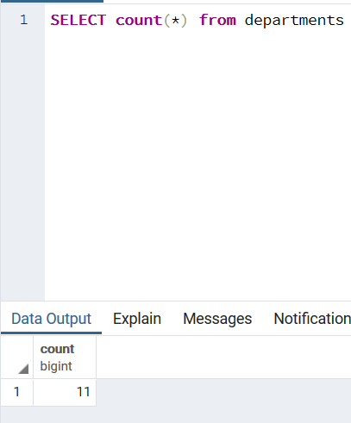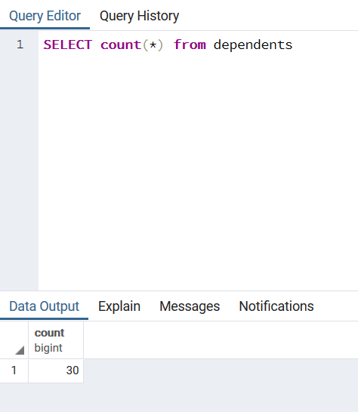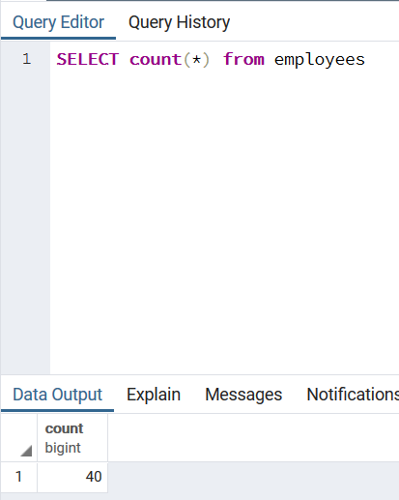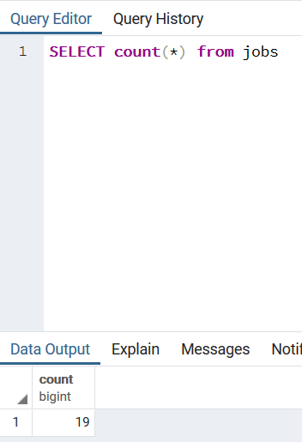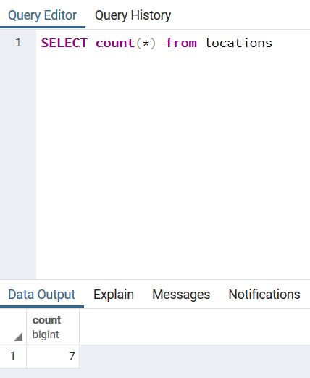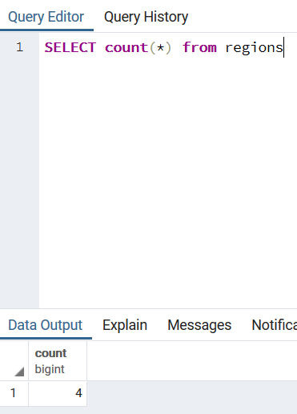

Step 3 – using PGModeler – connect to postgres and then import only the tables created in this lab (do not include CITY, COUNTRY and COUNTRYLANGUAGE) (2 marks)

